Object Literals and JSON

**Introduction**

JSON and Object Literals share many common characteristics. They both follow a name-value pair format. Name, which is also referred to as a property, identifies the raw value stored in the value portion of the data structure. A colon separates the property from the raw value. And, values are accessed through dot notation. For data structures with multiple properties, commas are used to separate them; however, there should not be a comma after the last name-value pair.

**Exhibit A. Fruit Object Literal**

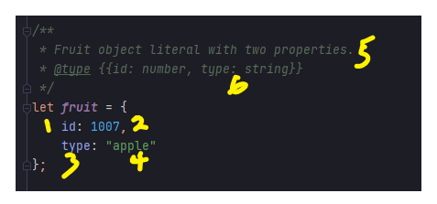

1. Property with a text value of id.
2. Raw value assigned to the id property.
3. Property with a text value of type.
4. Raw value assigned to the type property
5. Code comments explaining what the block of code represents.
6. Code comments identifying the objects properties

**Exhibit B. Fruit JSON Data Structure**

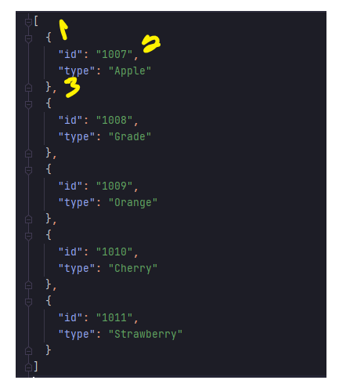

1. name-value pair for multiple Fruit objects.
2. Raw value assigned to the id property.
3. Comma separating multiple name-value objects.